Knockabout Cricket vs Why I Love Australia
Fill in the table with information that you have learnt from reading these books:
Knockabout Cricket | Similarities | Why I Love Australia

How many words can you make from the letters in the title of:
Knockabout Cricket
3 letter words | 4 letter words | 5 letter words | 6 letter words
More than 6 letters

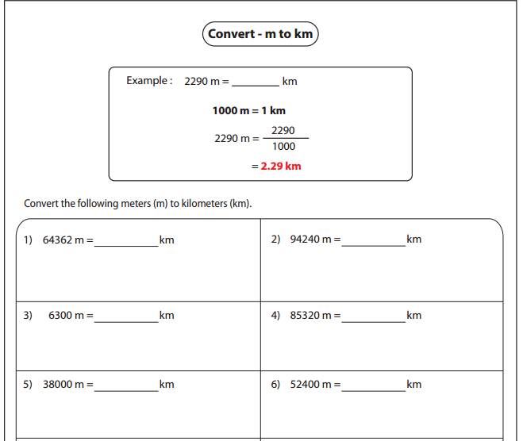

The distance from Raymond Terrace to each destination is recorded in metres. Convert these measurements to km:
Distance in metres (m) |  | Distance in kilometres (km)
Raymond Terrace to Canberra
= 443 100m
Raymond Terrace to Sydney
= 116 900m
Raymond Terrace to Brisbane
= 756 000m
Raymond Terrace to Melbourne
= 1 034 500m
Raymond Terrace to Perth
= 3 932 900m

